Debugging Report on Concatenation: 4/21/2015  
Known Problems from before:

1. Same Matrix convert S->T, then T->S, SLR (Upper right) results in error.  
Fixed, Isolated s2t and t2s functions from concatenate functions.

Convert M1 from S->T, then T->S

M1  
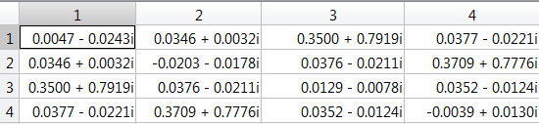

M1'  
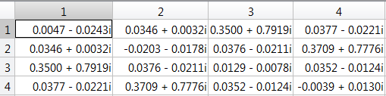  
Difference:  
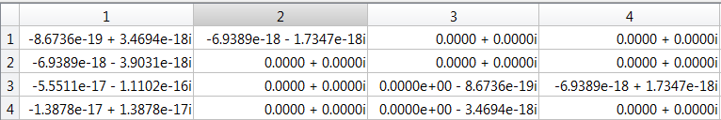  
Difference is almost zero. 18 to 19 digits accurate.   
Converting error solved. Hence, I am 99% confident that the converting algorithm is correct.

2. Matlab result is only 2 - 3 digits accurate from ADS  
Debugging steps

Step 1: Selecting the frequency and corresponding data   
Choose frequency: 1.5Ghz  
SNP1 : 3001th data  
SNP2 : 1500th data  
SNP3 : 3001th data

Step 2: Convert all 3 SNP to TNP using s2t function, then Multiply T1\*T2\*T3, then convert the product back to SNP.

We have 3 sets of results we need to compare.  
1. Manually checked @ 1.5GHz  
2. Results run through the whole concatenation function @ 1.5GHz (1501th data because DC added)  
3. Results from ADS @ 1.5GHz

Difference Result:

Manual vs. concatenation function result @1.5GHz  
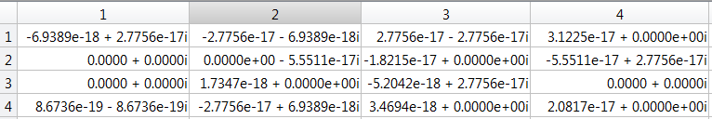  
essentially Manual check and Concatenation function results are the same.

Manual vs. ADS @ 1.5GHz  
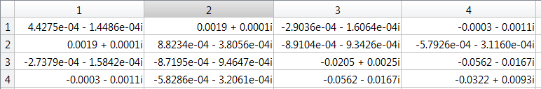

Conca. function vs. ADS @ 1.5GHz  
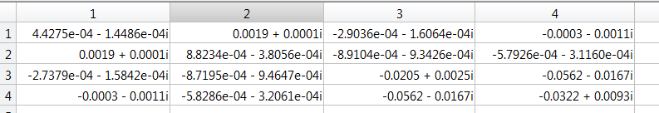

Manual checked is equal to Matlab results. Both are only 2 to 3 digits accurate to ADS results.

By doing this debugging technique, I eliminated the possible interpolation error. Still resulted in the 2-3 digits accuracy.   
Possible error:  
Used ADS incorrectly to generate ADS results. Checking with Yuan about ADS settings.